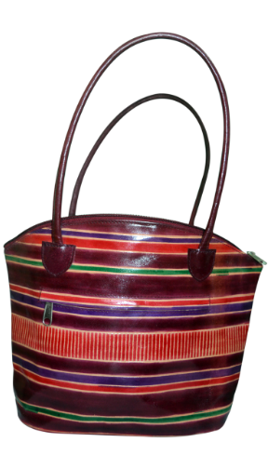

1. **Make Your Carriage Comfortable With This Beautiful Hand-Bag**

The bag is fabric-printed that demonstrates a gorgeous look and aesthetic presentation. It has been made from tanned leather that gives it desirable sturdiness. Suitably knit and patterned at various juncture to make it a lasting product. Works well as purse besides keeping shopping materials.

**Specifications**

**Material:** Stuffed and tanned leather of best quality is provided

**Color:**  Multiple and made appropriate fulfilling the demand of design.

**Equipment:**  Multiple chains are applied as and where required. There are several openings in order to put stuffs at various positions.

**Pattern:** Expert knit in machine.

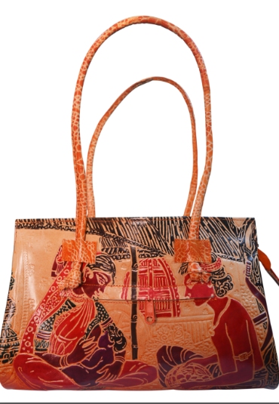

1. **Beautiful Hand-Bag Made For Ladies For An Appropriate Fashioned Styling**

The product displays both an austere look as well as depicts versatile stylish approach. It is made from eco-friendly cotton material and thus speaks for the company’s focus on environment keep-up. A distinctive wedding ceremony is demonstrated that picks the product as an ideal gift in such ceremony. Suitable knit at appropriate places has helped the product to become sturdy.

**Specifications**

**Material:** Company makes no compromise over quality. Best quality thick cotton is used with expert knitting technique for an appropriate coverage.

**Color:**  The color is applied as a combination of blackish and duple saffron.

**Equipment:**  Carriage has been made comfortable with application of straps. Chains are also applied at suitable places. Multiple pockets are provided for making the use handier.

**Pattern:** An expertly hand-crafted product.

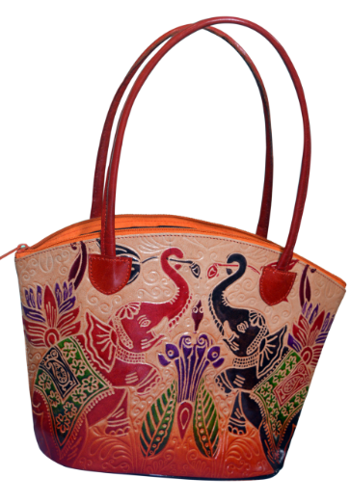

1. **Bags that makes your shopping more stylish and comfortable**

This product has also been made form eco-friendly material depicting company’s keen interest for being focused on eco-friendly material. The various print on the side of the bag clearly demonstrates that it has been designed for various religious occasions like Offerings, Weddings and similar other type. The user will feel more comfort in carrying as there is a long strap for this purpose

**Specifications**

**Material:** The product has been made from best quality cotton or jute. The thickness provides assurance for durability

**Color:**  The beautiful design on the side is red as well as black and peacock range depicts stylish embroidery of fine stitch.

**Equipment:**  Carriage has been made comfortable with application of straps. Chains are also applied at suitable places. Multiple pockets are provided to avert carriage of other bags for keeping money.

**Pattern:** Suitable designed in hand.

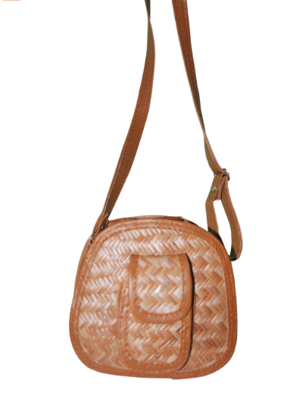

1. **Beautiful and stylish Handbag for ladies**

The product has been made from bamboo cane, an eco-friendly component. The look is highly gorgeous and makes an unbeatable fashion statement. Best use is while travelling and can be used for office-going too.

**Specifications**

**Material:** Thickest form of bamboo-cane is used in making the product. It speaks for the environment awareness of the manufacturer. Light and sturdy construction makes it easy to carry and durable too.

**Color:**  The bag itself is saffron and the long strap is bright maroon.

**Equipment:**  Long strap has made the carriage most handy, stylish and comfortable. Appropriate usage of multiple pockets has provided scopes for keeping gadgets and equips. Tiffin boxes, wallets etc., are the suitable insertions.

**Pattern:** One of the best hand-craft designs.

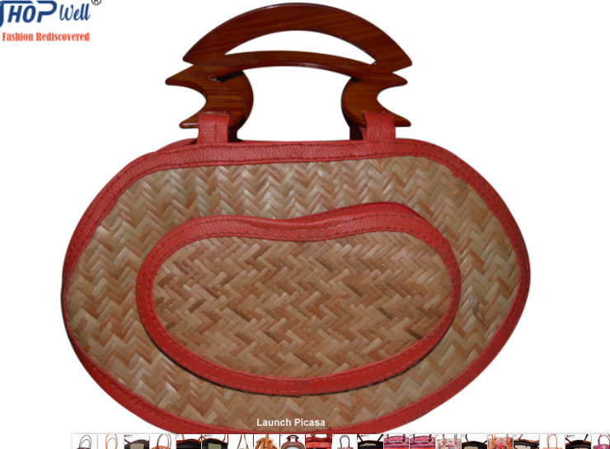

1. **Rare specimen – Hand bag made from string bamboo**

Interesting product – made entirely from bamboo string. It makes a beautiful carriage that makes local carrying a comfortable affair. The carriage imports a fine smart statement of fashion. Made for persons who looks for smart carriage

**Specifications**

**Material:**  The product is made from light-weight bamboo string. The double knit has made the product sturdier and thus durable. It makes a beautiful smart fashion statement.

**Color:**  The bag itself is off-whitish and the zip-opener has been given deep Cadbury color.

**Equipment:**  This bag may be carried, but it normally works best as a wallet-type handbag. It has no strap. Pockets are inserted for making it fit to keep various inputs.

**Pattern:** Made with expert handcraft.

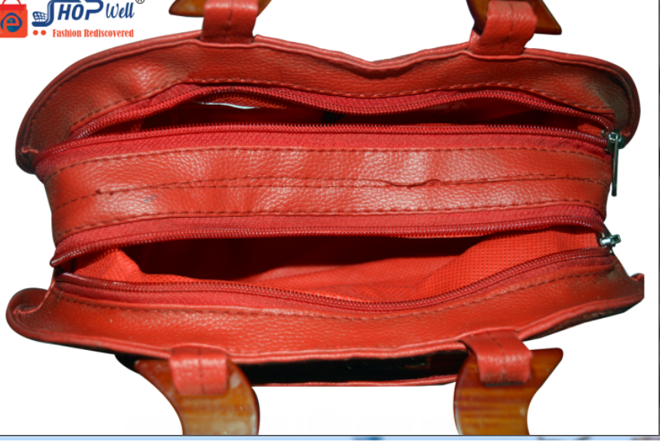

**NOT RELEVENT**

1. **Make the best use of a sophisticated Travel Bag**

The product has been made from stuffed leather. The construction has been made sturdier by use of thickest form of tanned leather. This is light-weight also to make it more comfortable for use

**Specifications**

**Material:**  Best quality leather has been used to make this product. The leather is tanned too in order to impart extreme toughness to it.

**Color:**  The color is red. The positions outlining chains are given chocolate blackish form.

**Equipment:**  Suitable straps are added in places. It can be carried both by hand and shoulder-straps are also provided. Pockets are provided for keeping important belongings. Chains are also suitably inserted.

**Pattern:** A beautiful and comfortable machine-made product.

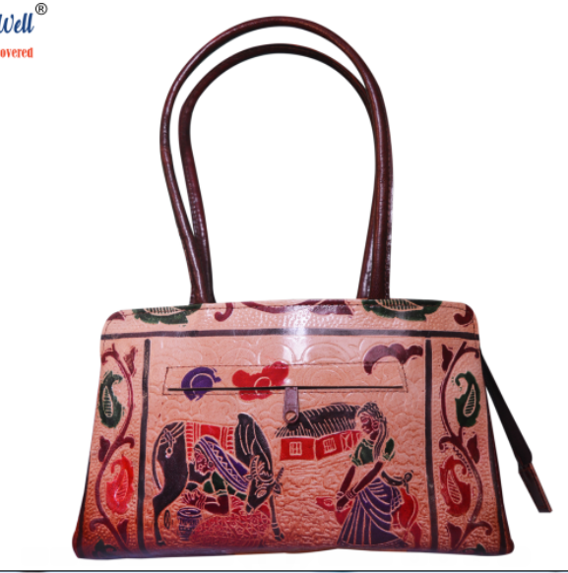

1. **Nice Mini Sophisticated Travel Bag Helps Your Journey For Auspicious Reason More Significant**

**Description:** This bag can be ideally used by ladies when they are out to attend for any auspicious occasion like wedding, birthday, festival of like for a few days. The attic prints definitely interprets that the product is exclusively meant for ladies. The various other depictions also refer the celebrative mood. Makes an occupant fashion statement

**Specifications**

**Material:**  Best quality jute/thick canvas is used in making this beautiful fashionable bag. The use of materials speaks for the environment-consciousness of the maker.

**Color:**  Use of multiple colors at various positions has made the product an attractive one. The attics are made black, red, blue and likewise. The main color component is whitish red.

**Equipment:**  There are straps that have made carriage both in hand as well as shoulder comfortable affair. Insertions of suitable pockets have made keeping of gadgets and other belongings easy and hiked.

**Pattern:** Expertly crafted from machine.

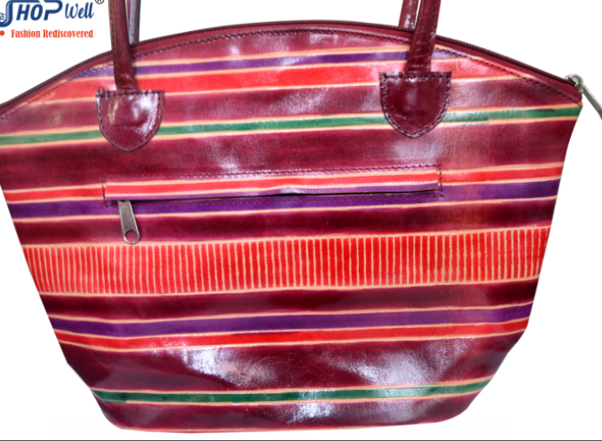

1. **Multi-color hand-bag has made travel more stylish and comfy**

**Description:** The Insertions of appropriate fabric fashions and designs has added a beautiful attraction to this product. This bag can both be used for local carriage, shopping as well as for short tours. This is ideal to demonstrate a fashion statement

**Specifications**

**Material:** Best quality stuffed leather is used in making this product

**Color:**  Usage of appropriate colors in various places increases attraction of the product.

**Equipment:**  Application of chains at suitable places has added to the utility. There are several openings in order to put stuffs at various positions.

**Pattern:** A symbolic machine-craft product.

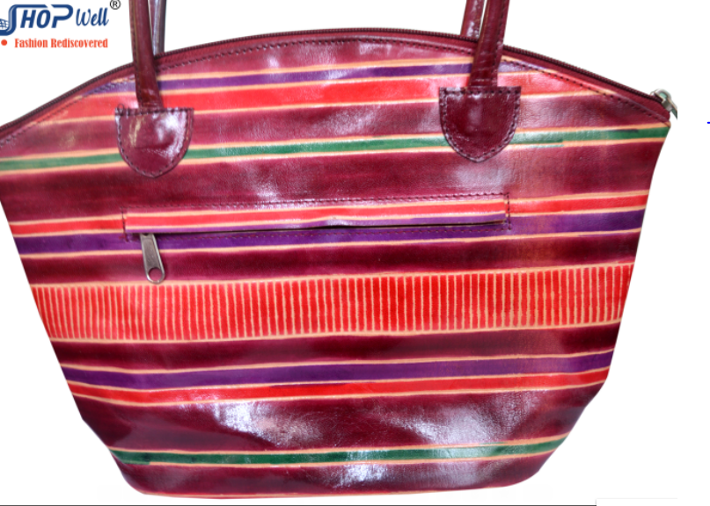

Looked same as previous products

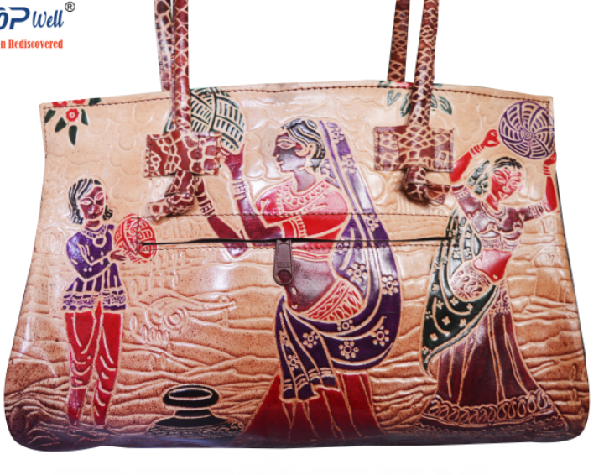

1. **Make your observations of festivities more meaningful with this statement**

**Description:** The bag is made with inclusions of fabric prints suitable for various places. From the demonstrations,, it looks to as if demonstrating any drum festival. Carrying such a carriage to any festive occasion will let the aesthetics of festival out.

**Specifications**

**Material:**  Made from thick canvas or Jute that speaks for sense of environment of the user and maker too.

**Color:**  Only one color of off-white is used. The prints are given their own colors

**Equipment:**  The product has one main chain at the outside. Use of various in-chains has been helpful in making provisions for keeping various other insertions.

**Pattern:**  Suitably hand-made product.

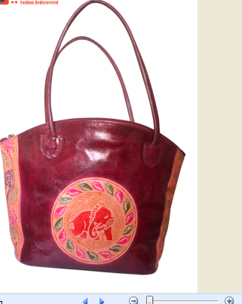

1. **Make your festival marketing with this product**

**Description:** The fabric print on the side of the bag resembles an art used in ‘Laxmi Puja’ during October. This outlook brings out a sense of devotion in mind. It produces a fantastic art presentation.

**Specifications**

**Material:**  The product is made of thick incarnation of Polyethylene. The eco-friendly approach was also observed.

**Color:**  Only Maroon color is used. The sides are given light pink.

**Equipment:**  The product has one main chain at the outside. The strap is made long to facilitate carrying process.

**Pattern:**  The product is expertly knit in machine.

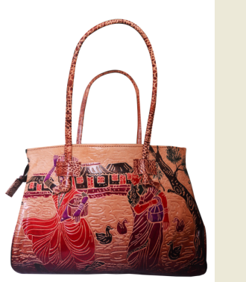

1. **A unique product for shopping**

**Description:** The fabric print on the side of the bag depicts a scene of drama or it may be a spectrum of village pond where two geese is also seen. It demonstrates a fascinating sculpture reproduction. The picture of village hut adds to the attractive features.

**Specifications**

**Material:**  The bag is made from best quality thick jute. NO compromising over the quality has made it sturdy and durable.

**Color:**  Pinkish white color is seen. The strap has design and thus seen as multi-colored.

**Equipment:**  The product has one main chain at the outside. The strap is made long to facilitate carrying process.

**Pattern:**  The product is expertly knit in machine.

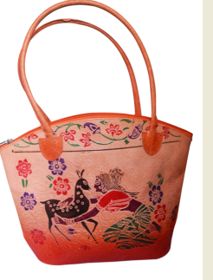

1. **Best of the product for ladies that is used for quack tours**

**Description:** The beautiful fabric print demonstration on the side of the bag depicts various specimens like horse, fish and various symbols. All these representations have increased the attraction of the product. Even the articulated prints on the top have made the product more gorgeous.

**Specifications**

**Material:**  The product demonstrates one of the best representations of Jute production. Superior quality hessian Jute fabric is used to make the bag. The thickness has added to the durability and made it tough too.

**Color:**  Pinkish white color is seen. The strap bears saffron color.

**Equipment:**  The product has one main chain at the outside. The strap is made long to facilitate carrying process.

**Pattern:**  One of the top machine-made products

.

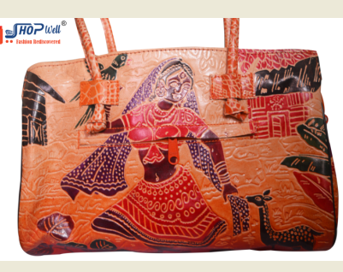

1. **Make a glamorous trip to ecstatic places with this suitcase bag**

**Description:** The product appears like a beautiful briefcase. The beautiful fabric print on the side has made the outlook very special. It depicts the picture of a girl cradling on a swing while different garden creature like deer, peacock are watching. Such a picture is really mind-scintillating.

**Specifications**

**Material:**  The product is made from eco-friendly material, probably from hessian Jute or stuffed canvas. The sturdiness has been brought about by use of double knit.

**Color:**  Pinkish white color is seen. The strap bears saffron color.

**Equipment:**  The product has multiple chains. Long strap has made carriage an easy process.

**Pattern:**  Expertly knit in machine.

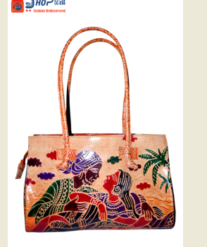

1. **Best ladies hand-bag for shopping**

**Description:** This product is suitably used for office-going and normal shopping. The fabric prints at the outside depicts beautiful nature of the outside. Thus, it simply made the products additionally attractive

**Specifications**

**Material:**  The product is made from eco-friendly hessian Jute or stuffed canvas. The sturdiness has been brought about by use of double knit.

**Color:**  Pinkish white color is seen. The strap bears saffron color.

**Equipment:**  The product has one chain as main opening. There are chains inside to make provisions for belongings.

**Pattern:**  Expertly knit in machine.

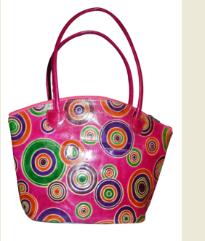

1. **Multi-print bag for local uses**

**Description:** The various fabric prints has made the product a multi-facet demonstration. This may not seem acceptable for all, but a few will simply jump at it.

**Specifications**

**Material:**  The product appears to be made from cotton or stuffed canvas. The awareness towards eco-friendliness has thus been demonstrated.

**Color:**  basic color is bright pink, and the various circles have their own color. Thus, the bag appears to have multiple colors. The strap has been given magenta outlook

**Equipment:**  The product has one main chain at the outside. The strap is made long to facilitate carrying process.

**Pattern:**  One of the best craft over machine.